Daniel Evers

1/18/2025

2-3 Project Proposal

1. Image used for 3D shapes

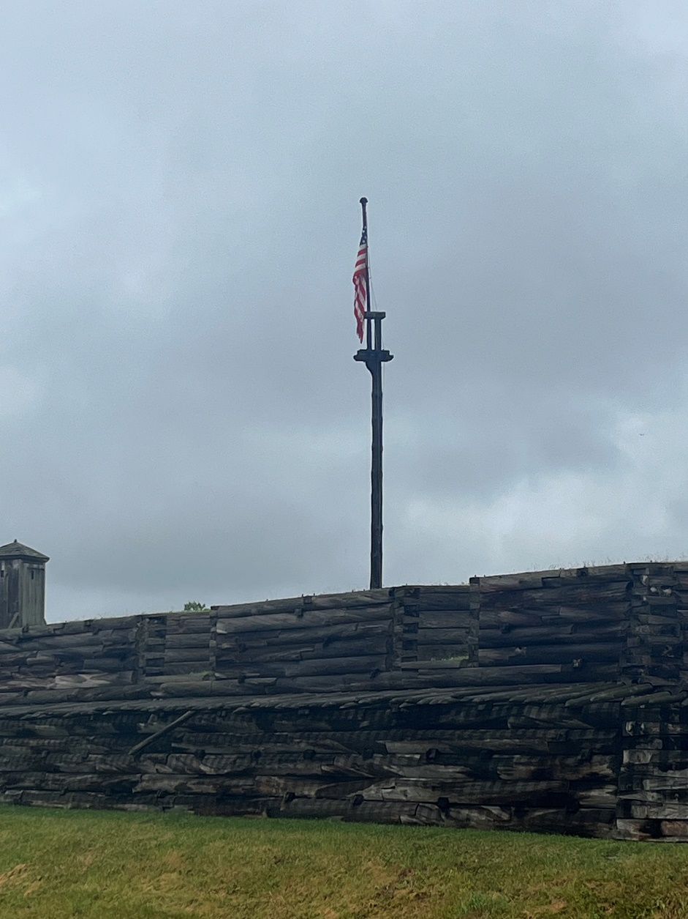

This is a picture I took of an old revolutionary fort in New York. This is on the outside of the fort looking in. One object that will be replicated into 3D is the flagpole. This a a good object to choose because it is in the center of the image and it is a main part of the image. It will also be simple to create because a cylinder can be used. A cylinder can be used to represent a flagpole. It is a good choice because a cylinder can be round and skinny just like a flag pole. A second object I can turn into 3D is the grass. This is a good object to represent in 3D because it is the base of the image, everything is built on the grass. A plane can represent the grass. A third object that can be represented in 3D is the watchtower that’s in the far left of the image. This is a good object to represent in 3D because it can combine 2 different shapes to make one object. I can use a box to represent the middle of the tower and a pyramid to represent the top of the tower. A fourth object that would be good to represent in 3D is the American Flag. This would be good because I can use a plane to represent the flag, and then use texture to show that it is waving or flapping in the wind. The last object from my image that would be good to represent in 3D is the fort wall. I would use a plane to represent the wall. I could use cylinders with a cone on top to show the parts that have defensive parts. I can use shading to represent the different colors in the image. The grass can be green with a little bit of yellow to represent the dry grass. I can add texture to the flag to represent if it is moving. I can use lighting and different colors to represent the sky being gray and a little overcast.